Electronics Documentation

Electronics Block Diagram
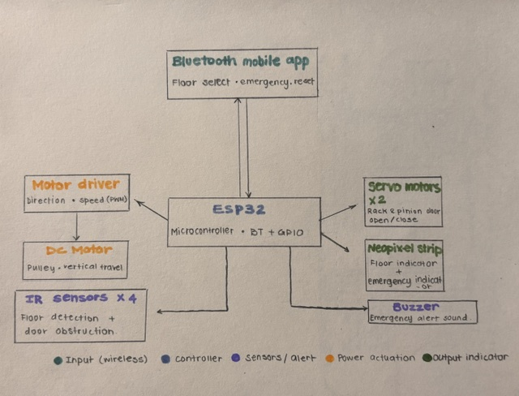

Components Table
Component | Quantity | Purpose | Justification
Servo Motor | 2 | To drive the rack and pinion mechanism for opening and closing the elevator doors | Provides controlled angular motion which can be converted into precise linear movement for smooth and synchronized door operation
IR Sensors | 4 | To detect elevator position at each floor and detect obstruction between doors | Allows accurate floor detection and ensures safety by preventing door closure when obstructed
ESP32 Microcontroller | 1 | To control all system operations and handle communication between components | Offers integrated Bluetooth capability and sufficient GPIO pins for managing multiple inputs and outputs
DC Motor | 1 | To drive the pulley system for vertical movement of the elevator | Provides continuous rotational motion required for lifting and lowering the elevator car
Motor Driver | 1 | To control the direction and speed of the DC motor | Required to interface the DC motor with the microcontroller and handle higher current safely
Bluetooth Mobile Application | 1 | To send control commands (floor selection, emergency, reset) to the system | Enables wireless user interaction and enhances usability of the system
Buzzer | 1 | To depict the emergency scenario | Usually, an elevator has a sound that goes off when the lift gets stuck or the emergency button is pressed
Neopixel Strip | 1 | To indicate what floor the elevator is on. | Elevators always have a small indicator for floors

